Chapter 8 Assignment

Assignment Steps:

1. You will first research and learn about one of the following accounting scandals
2. Prepare the assignment in one of the following formats
3. Hand in this cover sheet with your assignment

Your research must include the following:

1. an overview of the corporation
2. a summary of the scandal
3. a description of the scandal – explaining the specific accounting fraud that occurred
4. an explanation of how the company managed to hide its accounting fraud
5. a discussion of who the scandal affected – both inside and outside the company
6. recommendations regarding how we might avoid similar accounting frauds in the future

Choice of Formats (select 1 of the following):

1. Report - minimum of 3 pages with headings and/or sub-headings, charts, tables, etc.
2. PPT - minimum 30 slides (print 6 slides on a page)
3. Infographic - must have all required information with tables, charts, graphics, etc.

Student Name: Dhrumil Patel

Accounting Scandal: WorldCom Scandal

Marking Scheme

|  |  |
| --- | --- |
| **Category and Criteria** | **Mark** |
| Knowledge   * The topic was completely explained * Internal controls discussed | 10 |
| Thinking   * Research is evident * Solid discussion on stakeholders * Citations provided | 10 |
| Application   * Examples provided * Transactions explained * Avoidance strategies explained | 10 |
| Communication   * Professional * Creativity using tables, charts, graphics, etc * Grammar | 10 |

## Overview: What was WorldCom?

WorldCom had become America’s biggest telecommunications company by 2001 and was only getting bigger - they had expanded into most, if not all, of the available markets and held a near-monopoly on the industry. Their explosive growth came from a series of mergers and acquisitions in the 1980s and 90s; buying profitable businesses that were performing about equally well as themselves enabled them to rely on the groundwork laid out by other companies, helping them grow faster. This was an exceedingly successful business model for more than a decade, but required high upfront costs and lead to significant inefficiency. Moreover, the 1980s and 90s saw the emergence of cell phones and the internet, creating ideal circumstances for WorldCom to offset the costs of acquisitions and mergers as their products and services were becoming increasingly popular and lucrative.

As WorldCom continued with their mergers and acquisitions, their stock became increasingly attractive for investors. As seasoned analysts like Jack Grubman recommended their clients to buy stocks of up-and-coming companies like WorldCom, who had high-profit models and could pivot quickly. These expert analysts had the reputation and trust to even coordinate deals between companies that were ideal targets for WorldCom to acquire. Analysts like Grubman made their clients millions of dollars while also fuelling WorldCom’s growth, with WorldCom eventually bringing in $950 million by 1992.

From 1993 to 1999, WorldCom acquired bigger companies, growing bigger and reaching for a near-monopoly. Over the course of these mergers and acquisitions, WorldCom’s stock peaked at $64.50 per share and the executives were paid, at most, 531 times the amount that their regular employees were being paid. WorldCom’s biggest acquisition is of a major competitor, MCI, for $36.5 Billion ($56 billion adjusted for inflation), and they attempted to go even further by trying to acquire another huge competitor, Sprint. This aroused suspicion from the European Union and the DOJ for concern that WorldCom was reaching a monopoly over the telecommunications industry in America. Unbeknownst to most, the WorldCom scandal had been in the making for a few years.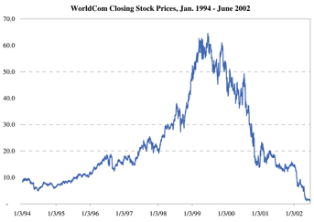

## The Scandal: What happened?

The WorldCom scandal began in 2000 as an attempt for the company managing WorldCom’s finances, Arthur Anderson, to help WorldCom appear more profitable through “earnings management”. The committee in charge of WorldCom’s accounting was pressed to perform a subtle but shady accounting practice to make the company look better. At the same time, the stock market takes a hit in every sector and most other telecom companies’ stocks are falling as well. Members of an internal auditing committee dig into the company’s accounting and notice that the board of directors has loaned millions of dollars to the company’s CEO, Bernard “Bernie” Ebbers, who bought many shares on margin. Not wanting the CEO’s millions of shares to flood the market, the board of directors let the CEO loan more money from the business, with the expectation that the stock will rise again and the company would recoup the losses. Over 18 months, Bernie takes out over $900 million in loans, but the stock continues to fall. By 2002, WorldCom shares have fallen over 75% from all-time highs, being valued at $15 per share. Bernie’s actions can no longer be excused and he resigns. Those who remain at the company attempt to salvage the company, but the internal auditing committee finally sees the shady accounting practices. While the internal auditing committee unravels more of WorldCom’s malpractice, WorldCom’s stock falls to an all-time low of $0.83. The SEC begins an investigation and calls WorldCom’s executive leadership to court, almost all of whom invoke their 5th amendment right not to testify in the case that they would incriminate themselves. WorldCom then declares bankruptcy, listing $41 billion in debt and $107 billion in assets.

|  |  |  |  |  |  |
| --- | --- | --- | --- | --- | --- |
| Summary of Accounts (in millions of dollars) | | | | | |
| Financial Statement Area | 1999 | 2000 | 2001 | 2002 | Total |
| Revenue | 205 | 328 | 358 | 67 | 958 |
| SG&A | 46 | 283 | 181 | 25 | 535 |
| Line Costs | 598 | 2870 | 3063 | 798 | 7329 |
| Other | 89 | 393 | 4 | 50 | 428 |
| Total | 938 | 3874 | 3598 | 840 | 9250 |

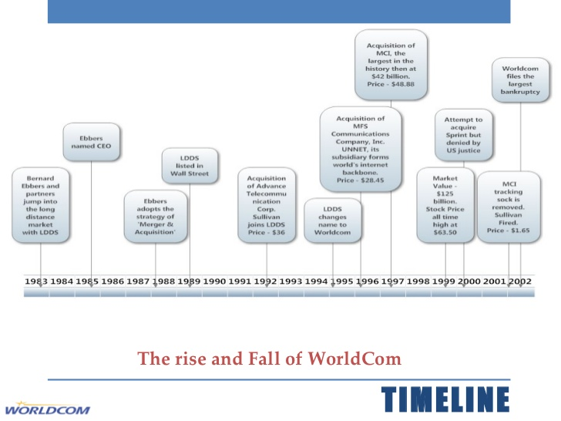

## The Scandal in More Detail

WorldCom’s scandal was not a very complicated one - to cook their books, WorldCom greatly inflated their net income by hiding their expenses to hide that the business was failing by employing multiple suspicious accounting practices that took advantage of existing, legitimate accounting practices. In 2001, WorldCom reported a net profit of $1.4 billion but should have actually reported a net loss during the fiscal periods of 2001 and the first fiscal period of 2002. Although this fraud may be thought of as the largest contributing factor to WorldCom’s demise, the business had already been failing by 2001, and the fraud only delayed their inevitable bankruptcy.

## The Scandal: How did they hide it?

WorldCom’s accounting committee used “earnings management” to perform non-GAAP accounting practices and recorded their operating expenses as investments instead of expenses. This method often goes hand-in-hand with fraud and became problematic for the internal auditing committee. Specifically, they recorded certain expenses under the account “Prepaid Capacity”, a meaningless term simply used to take advantage of amortization. By splitting operating expenses into capital expense accounts, WorldCom was able to split the value of these expenses over several periods instead of reporting them immediately on the income statement. This enabled WorldCom to inflate their net income, as they did in 2001 when the company reported $1.4 billion in profit. However, if the operating expenses had been recorded properly, WorldCom would have actually been at a loss for the fiscal periods in 2001 and the first fiscal period of 2002.

## Who Was Affected?

Inside the company, upper management was strapped with a multitude of fines and charges. The CEO, Bernard Ebbers, was sentenced to 25 years in jail, which he is still serving to this date, the CFO, Scott Sullivan, was sentenced to 5 years in jail, and the company fell hard. The company’s bankruptcy was the largest in America until the recession of 2008, with a debt of about $41 billion. Tens of thousands of employees found themselves jobless once the company collapsed, and WorldCom’s former banks would settle lawsuits with creditors for about $6 billion. The banks, however, denied any liability with WorldCom’s scandal.

## Lasting Effects

The sheer size and magnitude of the WorldCom scandal represented the final nail in the coffin for disclosure requirements and penalties for fraudulent accounting for American businesses. This lead to the development of the Sarbanes-Oxley Act in 2002, a monumental movement in the American legislature to crack down on fraudulent accounting. The act gave audit committees wide leverage in overseeing top management’s decisions and made top management personally responsible for the accuracy of financial reports. This enabled the American government to be able to point at a specific person or team when uncovering fraud as they had to personally certify financial documents. Moreover, Sarbanes-Oxley requires public companies to perform extensive internal controls tests and create reports for annual audits. This great step forced many businesses to scale their accounting systems to be more efficient, centralized, and automated to keep up with the requirements imposed by Sarbanes-Oxley.

Works Cited

(n.d.). Retrieved from https://www.sec.gov/Archives/edgar/data/723527/000093176303001862/dex991.htm.

Kennon, J. (2019, September 16). How One of the World's Largest Companies Made $3.8 Billion Disappear. Retrieved from https://www.thebalance.com/worldcom-s-magic-trick-356121.

Kenton, W. (2019, March 21). WorldCom. Retrieved from https://www.investopedia.com/terms/w/worldcom.asp.

Piancey, C. (2018, August 28). WorldCom and The Fraud That Was. Retrieved from https://medium.com/@thecaspiancey/worldcom-and-the-fraud-that-was-10dd3433b643.